Flexamat – Tied Concrete Block Mats

DESCRIPTION
Flexamat – Tied Concrete Block Erosion Control Mats
This work shall consist of furnishing and placing the Flexamat system in accordance with this specification and conforming with the lines, grades, design, and dimensions shown on the plans.

MATERIALS
Flexamat is manufactured from individual concrete blocks tied together with high strength polypropylene bi-axial geogrid. Each block is tapered, beveled and interlocked and includes connections that prevent lateral displacement of the blocks within the mats when they are lifted for placement.
Tied Concrete Block Mats shall be Flexamat, manufactured by Motz Enterprises, Inc. or approved equal (See Section 3, Alternative Products).

Blocks. Furnish blocks manufactured with concrete conforming to the cement requirements of ASTM C150 and to the aggregate requirements of ASTM C33. Meet a minimum compressive strength of 34.5 MPa at 28 days. Furnish blocks that have a minimum weight of 1.36 kg per block. Blocks shall be placed no further than .51 mm apart.

Polypropylene Bi-Axial Geogrid. Provide revetment mat that is constructed of a high tenacity, low elongating, and continuous filament polypropylene fibers that is securely cast into and embedded within the base of the concrete blocks and obtains connection strength greater than that of the geogrid. Ensure the geogrid meets the requirements of Table 1:
Table1
Polypropylene Bi-Axial Geogrid
Description | Requirement
UV Stabilization | 2% Carbon Black
Ultimate Tensile Strength | 30 KN/M (MD), 30 KN/M (CMD)

Underlayment Materials – Three backing options:
- Standard Flexamat – Includes Curlex® II backing
- Flexamat Plus – Includes both Curlex® II and Recyclex TRM-V
- Flexamat with Filter Fabric – Includes non-woven filter fabric backing.
The backing material shall be packaged within roll of Flexamat.

Curlex® II:
Curlex II erosion control blanket (ECB) consists of a specific cut of naturally seed free Great Lakes Aspen curled wood excelsior with 80% one hundred fifty millimeter fibers or greater fiber length. It is of consistent thickness with fibers evenly distributed throughout the entire area of the blanket. The top and bottom of each blanket is covered with degradable polypropylene netting.

Index Property Test Method Value
Thickness ASTM D 6525 0.418 in (10.62 mm)
Light Penetration ASTM D 6567 34.6%
Resiliency ASTM D 6524 64%
Mass per Unit Area ASTM D 6475 0.57 lb/yd² (309 g/m²)
MD-Tensile Strength Max. ASTM D 6818 127.0 lb/ft (1.9 kN/m)
TD-Tensile Strength Max. ASTM D 6818 50.9 lb/ft (0.7 kN/m)
MD-Elongation ASTM D 6818 28.64%
TD-Elongation ASTM D 6818 29.84%
Swell ECTC Procedure 89%
Water Absorption ASTM D 1117/ECTC 199%
Bench-Scale Rain Splash ECTC Method 2 SLR = 6.84 @ 2 in/hr ^{2,3}
Bench-Scale Rain Splash ECTC Method 2 SLR = 7.19 @ 4 in/hr ^{2,3}
Bench-Scale Rain Splash ECTC Method 2 SLR = 7.56 @ 6 in/hr ^{2,3}
Bench-Scale Shear ECTC Method 3 2.6 lb/ft² @ 0.5 in soil loss ³
Germination Improvement ECTC Method 4 645%

¹ Weight is based on a dry fiber weight basis at time of manufacture. Baseline moisture content of Great Lakes Aspen excelsior is 22%.

² SLR is the Soil Loss Ratio, as reported by NTPEP/AASHTO. ³ Bench-scale index values should not be used for design purposes.

Recyclex® TRM:
Recyclex TRM – V is a permanent non-degradable Turf Reinforcement Mat (TRM), consists of 100% post-consumer recycled polyester (green or brown bottles) with 80% one hundred twenty seven millimeter fibers or greater fiber length. It is of consistent thickness with fibers evenly distributed throughout the entire area of the TRM. The top and bottom of each TRM is covered with heavy duty polypropylene net. Fibers are tightly crimped and curled to allow fiber interlock, and to retain 95% memory of the original shape after loading by hydraulic events. Fibers have a specific gravity greater than 1.0; therefore, the blanket will not float during hydraulic events. Recyclex TRM – V meets Federal Government Executive Order initiatives for use of products made from, or incorporating, recycled materials. Recyclex TRM – V shall be manufactured in the U.S.A. and the fibers shall be made from 100a% recycled post-consumer goods.

Index Property Test Method Value
Thickness ASTM D 6525 0.294 in (7.47 mm)
Light Penetration ASTM D 6567 57%
Resiliency ASTM D 6524 86%
Mass per Unit Area ASTM D 6566 0.50 lb/yd² (271 g/m²)
MD-Tensile Strength Max. ASTM D 6818 295.2 lb/ft (4.32 kN/m)
TD-Tensile Strength Max. ASTM D 6818 194.4 lb/ft (2.85 kN/m)
MD-Elongation ASTM D 6818 32.2%
TD-Elongation ASTM D 6818 40.8%
Swell ECTC Procedure 8%
Water Absorption ASTM D 1117/ECTC 33.8%
Specific Gravity ASTM D 792 1.21
UV Stability ASTM D 4355 (1,000 hr) 80% minimum
Porosity Calculated 97.5%
Bench-Scale Rain Splash ECTC Method 2 SLR = 4.13 @ 2 in/hr ^{1,2}
Bench-Scale Rain Splash ECTC Method 2 SLR = 4.97 @ 4 in/hr ^{1,2}
Bench-Scale Rain Splash ECTC Method 2 SLR = 5.99 @ 6 in/hr ^{1,2}
Bench-Scale Shear ECTC Method 3 2.40 lb/ft² @ 0.5 in soil loss ²
Germination Improvement ECTC Method 4 353%

¹ SLR is the Soil Loss Ratio, as reported by NTPEP/AASHTO. ² Bench-scale index values should not be used for design purposes

10oz non-woven filter fabric:

The underlayment material shall be packaged in roll of Flexamat and shall meet the following characteristics:
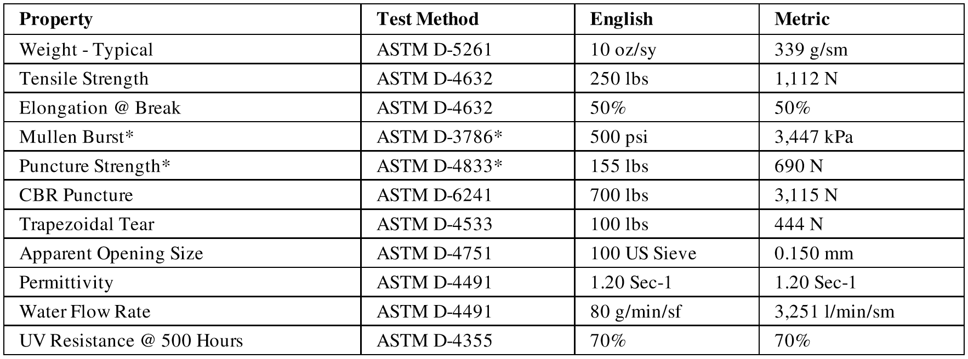

Cover the mat or otherwise protect it during long periods of storage to protect against degradation of the backing material as recommended by the manufacturer.

Mats will be rolled for shipment and are packaged with handling straps. These handling straps shall only be used for lifting below .61 m to place heavy duty lifting straps under rolls. Upon delivery, rolls may be left exposed for up to 30 days. If exposure will exceed 30 days, cover or tarp the rolls to minimize UV exposure.

All mats to be inspected upon delivery. Assure that all units are sound and free of defects that would interfere with the proper placing of the unit or impair the strength or permanence of the construction.
Chipping or missing concrete resulting in a weight loss exceeding 15% of the average weight of a concrete unit is grounds for rejection by the engineer. Replace, repair or patch the damaged areas per the manufacturer’s recommendations.

alternative Products
Alternative products may be considered if composition matches the materials detailed in Section 2. Such products must be pre-approved in writing by the Engineer prior to bid date. Alternative product packages must be submitted to the Engineer a minimum of fifteen (15) days prior to bid date. Submittal packages for alternate products must include, as a minimum, the following:
- Product Properties – Composition of materials, stating product is comprised of the following components:

Concrete Blocks - minimum compressive strength of 34.5 MPa at 28 days. Furnish blocks that have a minimum weight of 1.36 kg per block. Blocks shall be placed no further than .51 mm apart.
  - Polypropylene Bi-Axial Geogrid – minimum tensile strength of 30 KN/M (MD), 30 KN/M (CMD).
  - Underlayment - Minimum of a double-net excelsior (wood fiber) blanket, plus additional turf reinforcement or filter fabric as specified by design engineer. Underlayment must be packaged within the Tied Concrete Block Mat rolls.
- Full-Scale laboratory testing performed by an independent 3rd party testing facility with associated engineered calculations certifying the hydraulic capacity of the proposed Tied-Concrete Block Erosion Control Mat meets the performance requirements listed in Section 4 of this specification.
- A list of 15 comparable projects in terms of project size, application and material dimensions in the United States, where the results of the specific alternative material’s use can be verified and reviewed for system integrity and sustained after a minimum of 5 years of service life.

Performance
Full-Scale laboratory testing performed by an independent 3rd party testing facility with associated engineered calculations certifying the hydraulic capacity of the proposed Tied-Concrete Block Erosion Control Mat meets the following requirements:
Test | Tested Value | Bed Slope | Soil Classification | Limiting Value
ASTM 6460 | Shear Stress | 30% | Sandy Loam (USDA) | 1149 Pa
ASTM 6460 | Velocity | 20% | Loam (USDA) | 9.1 m/s

Equipment
Provide the proper equipment to place the mat that will not damage the mat material or disturb the top soil subgrade and seed bed.

Construction

Prior to installing Flexamat, prepare the subgrade as detailed in the plans. All subgrade surfaces to be smooth and free of all rocks, stones, sticks, roots, and other protrusions or debris of any kind that would result in an individual block being raised more than 19 mm above the adjoining blocks. When seeding is shown on the plans, provide subgrade material that can sustain growth.

Ensure the prepared subgrade provides a smooth, firm, and unyielding foundation for the mats. The subgrade shall be graded into a parabolic or trapezoidal shape to concentrate flow to middle of mat or mats.

When vegetation is required, distribute seed on the prepared topsoil subgrade before installation of the concrete mats in accordance with the specifications.
Install mats to the line and grade shown on the plans and per the manufacturer’s guidelines. The manufacturer or authorized representative will provide technical assistance during the slope preparation and installation of the concrete block mats as needed.

Provide a minimum .46m deep concrete mat embedment toe trench at all edges exposed to concentrated flows. Recess exterior edges subject to sheet flow a minimum of 76.2 mm.

When needed, provide fastening or anchoring as recommended by the manufacturer or engineer for the site conditions.

For seams parallel to the flow line in ditch or channel applications, center a minimum .91 m wide strip of soil retention blanket under the seam. Fasten along the seam at 1.5 m maximum spacing. Parallel seams in the center of the ditch shall be avoided when possible.

Shingle seams perpendicular to the flow line with the downstream mat recessed a minimum of 2 blocks under the upstream mat and fastened together along the seam at .61 m maximum spacing if required by manufacturer or engineer.

Measurement
This Item will be measured by the square foot as shown on the plans, complete in place.

payment
The work performed and materials furnished in accordance with this Item and measured as provided under “Measurement” will be paid for at the unit price bid for “Flexamat”. This price is full compensation for loading and transporting, placing concrete block mats; excavation and disposal; furnishing topsoil and bedding; and equipment, labor, materials, tools, and incidentals.

